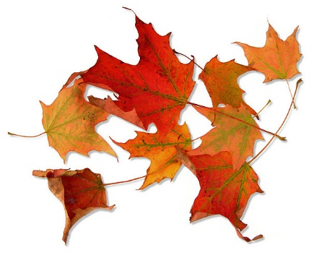
VILLAGE OF MIDDLEVILLE
FALL COLOR TOUR
Wednesday, October 17
10:00 a.m. – 2:00 p.m.

Come enjoy a golf cart ride along the beautiful Paul Henry Thornapple Trail. Refreshments will be served in the Community Pavilion across from the Village Hall at 100 E. Main Street. The event is free and reservations are not needed. In case of rain, the event will be held on Thursday, October 18.

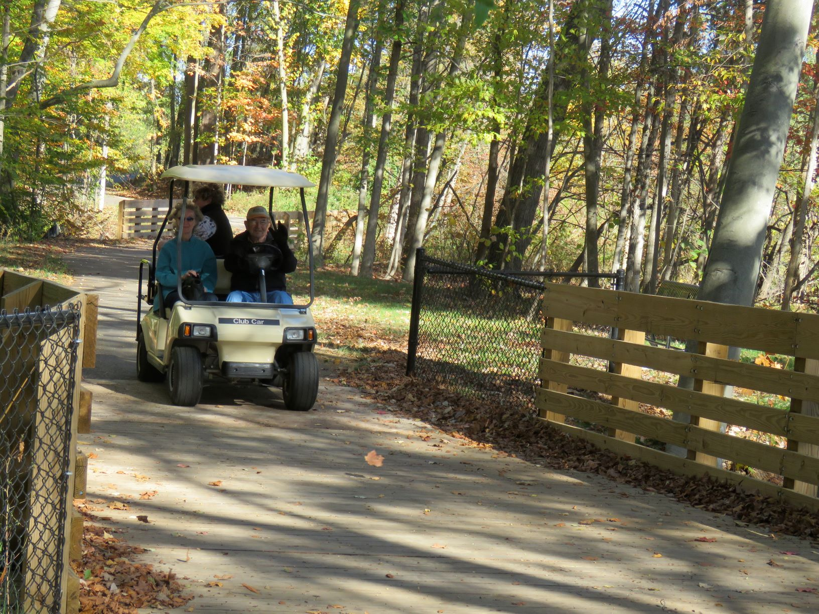

MANY THANKS TO THIS YEAR’S COLOR TOUR SPONSORS:
ADVANCED STONE AND TILE
CHEMICAL BANK
FARM BUREAU INSURANCE
HASTINGS CITY BANK
PHARMACY CARE

